**Alec Mabhiza Chirawu - 亚历克上 - M202161029**

**Wireless Communication - Assignment 2**

Signal Presentation:

Different inputs results in different outputs,

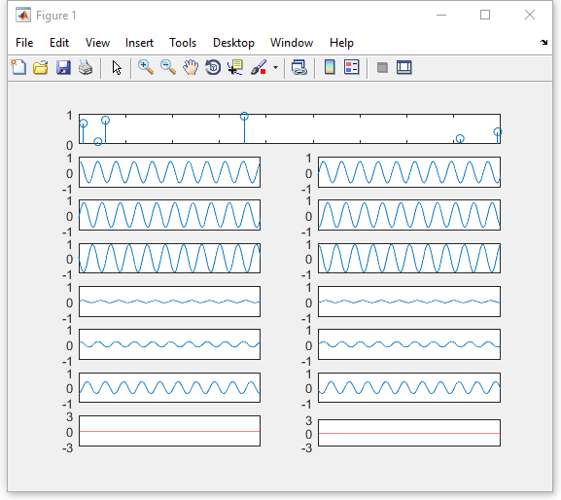

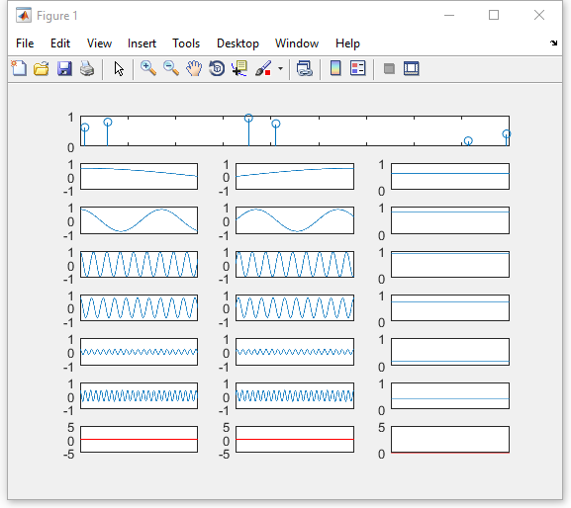

Matlab code that calculate not only frequency shift but also the angle(theta) to figure out the location of the train more easily.

Doppler shift at specific time:





